In the literature there is no reliable data about the preventive effectiveness of oxolin to treat influenza. Our team has decided to investigate this issue.

The research was conducted during the 1969 epidemic in one of the cities of the Soviet Union.

At the height of the epidemic wave, 4170 children aged 1-7 years from 40 child care centers were subjected to oxolin treatment from the time when they got up in the morning.

Due to the fact that the virucidal effect of the ointment manifests itself only when it is applied externally, oxolin was administered in the form of a vaseline-based 0.25% ointment. Lubrication of the nasal mucous membrane was conducted twice a day (morning and evening) over the period of 40 to 49 days. The consumption of material per 1 child per day was 0.3-0.5 grams. On Saturdays and Sundays the preparation was given to parents (in special tubes) for home use.

To obtain objective data on the efficacy of the medication, the study was carried out in accordance with the WHO recommendations, using the "double-blind" method. Oxolin (preparation #1) and placebo-vaseline (preparation #2) were encoded at our institute. The groups were composed by the method of "random grouping" in accordance with the Russian alphabetical order. (*Translator’s note. The Russian alphabet has 33 letters. For the purpose of the study the researchers divided the alphabet in half.*) In each group of the child care center, the children with the surnames beginning with the Russian letters “A” to “H” inclusive were given preparation № 1, while those with the surnames beginning with the Russian letters “O” to “Я» received preparation № 2. The health workers who conducted the preventive work were not aware of the difference between the medications.

All children were under constant medical supervision and doctors recorded all the changes in their condition in special printed journals.

Records of morbidity were kept for the total number of cases of influenza and acute respiratory infections of the upper respiratory tract starting 48 hours after the first lubrication and up to 40-49 days inclusive.

Serological examinations were carried out to determine the etiology of the epidemic. The serums were studied using the hemagglutination-inhibition reaction (HI test) to diagnose influenza virus A2 (Gongonk-1/68) and inhibitor-resistant vaccine viruses A2 (Leningrad) 135/65, B (Leningrad-2/67). The reaction was based on the utilization of 4 agglutinating units of the virus during an 18-hour cold exposure of serum antigens dilutions and the application of 0.75% chicken erythrocytes. The virus was isolated from nasopharyngeal flushes by infecting chicken embryos.

The materials of virological studies indicate that during the 1969 epidemic the 1968 Hong Kong variant of the influenza A2 virus was predominant in the circulation. Two strains of A2 influenza virus (Hong Kong 1/68) were isolated from nasopharyngeal flushes obtained from 20 influenza patients, who were examined in a group with 1 analysis performed on 10 patients. The results of the serological study confirm these data. The highest percentage of seroconversions was recorded for strain A2 (Hong Kong 1/68).

Most children tolerated well the twice daily lubrication of their nasal mucous membranes with the 0.25% oxolin ointment. Only 0.6% of the children who received oxolin developed various adverse reactions, while 0.9% of such cases were recorded in the control group.

The use of oxolin during the influenza epidemic reduced the disease incidence among children receiving the medication by 1.7 times (43%) relative to the control group (based on statistically reliable data). There was no significant difference in the indicators of effectiveness among children of different age groups (1-3 year olds and 4-7 year olds).

Preventive use of oxolin affected the clinical course of diseases (see Table). The children in the control group developed severe and complicated forms of influenza 1.1 to 1.4 times more often than in those who received oxolin. The average duration of the disease among the children under oxolin "protection" was 1.2 days shorter than in the control group.

The incidence of pneumonia, bronchitis, and angina in child care centers, which was 1.1-1.5 times less in children who received oxolin, indirectly corroborates the effectiveness of oxolin prevention.

The drug had a certain impact on the dynamics of influenza incidence in child care centers (see Figure). The epidemic process in the control and experimental groups followed different patterns. Before and after the start of the trial, the intensity and dynamics of the epidemic process in both groups were roughly similar. During the period of application, the prevalence rate among the children receiving oxolin decreases and the prevalence curve declines, while it continues to increase among the children in the control group.

The methods of chemoprophylaxis and epidemiological monitoring proved to be quite convenient for use in child care centers. Preventive application of oxolin during the beginning of the influenza pandemic (express prophylaxis) in groups of children selected by the random sampling method demonstrates a statistically significant decrease in morbidity of 1.7 times (43%).

We believe that the absence of differences in the indicators of effectiveness among children in the 1-3 and 4-7 year age groups confirms the fact that oxolin serves as a protective barrier. Apparently, this medication is not absorbed into the blood stream; oxolin is effective when it is present on the mucous membrane of the nose (the entrance gate for the infection).

In our opinion, the low percentage (0.6) of adverse reactions in children who received 0.25% oxolin ointment and the fact that this figure is lower than in the control group indicates that the drug is harmless.

Preventive use of oxolin alleviates the clinical course of disease and shortens its duration.

We believe that it is possible to increase the protective preventive action of oxolin and simplify the method of its introduction into the body. The preparation should not be used in the form of ointments, but rather as viscous solutions similar to vaseline oil that attach well to the mucous membrane of the nasopharynx. This will allow oxolin to be applied with a sprayer, irrigating not only the mucous membrane of the nose, but also the nasopharynx.

Conclusions

1. Prophylactic use of 0.25% oxolin ointment at the beginning of the influenza epidemic accounted for 1.7 times (43%) decrease in the disease prevalence in the group of children who received the drug compared to the control group. The medication has an impact on the dynamics of the epidemic process.

2. Oxolin has been demonstrated to be harmless when used externally over a long period of time (up to 49 days).

3. The use of the medication for preventive purposes alleviates the severity of the clinical course of the disease and shortens its duration.

4. Chemoprophylaxis and epidemiological monitoring methods proved to be quite convenient in the context of child care centers.

Figure 1. Influenza and other respiratory illness rates (in absolute numbers) broken into five-day intervals. Lines correspond to children 0-14 years of age and 7 years of age. The period of influenza application was indicated using a black square.

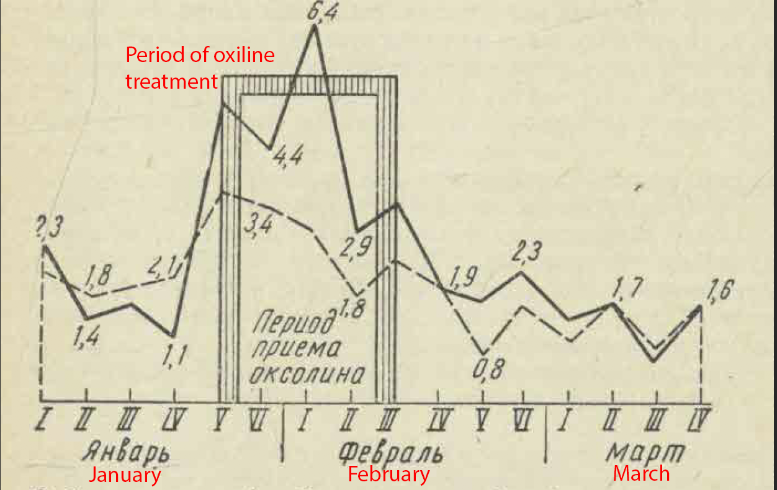

Table 1. Epidemiological effectiveness of oxoline prophylaxis against influenza in children

